Supporting information

Hot electron back-injection from plasmonic Au nanoparticles boosts photocatalytic CO₂ reduction over boron-doped spherical g-C₃N₄
Xianghai Song ^{a,} *, Huiling Zhao ª, Sheng Xu ª, Xiang Liu ^{b}, Mei Wang ^{c,} *, Weiqiang Zhou ª, Jisheng Zhang ª, Yuanfeng Wu ^{d}, Panpan Zhang ^{e}, Pengwei Huo ^{a,} *
ª Institute of Green Chemistry and Chemical Technology, School of Chemistry and Chemical Engineering, Jiangsu University, Zhenjiang 212013, China
^{b} Jiangsu Higher Vocational College Engineering Research Center of Green Energy and Low Carbon Materials, Zhenjiang College, Zhenjiang 212028, China
^{c} School of Agricultural Engineering, Jiangsu University, Zhenjiang 212013, China
^{d} School of Chemistry and Chemical Engineering, Henan Polytechnic University, Jiaozuo 454003, China
^{e} School of Material Science and Engineering, Jiangsu University, Zhenjiang 212013, China

Characterization
X-ray diffraction (XRD) analysis was performed on a Rigaku X-ray diffractometer with Cu Kαradiation, (Japan, XRD-6100), with a scanning range 10° to 80° and a scanning rate of 10° min⁻¹. Fourier transform infrared (FT-IR) spectra were obtained in the wavelength range 500-4000 cm⁻¹, using a Nicolet Magna-IR 550 spectrometer with KBr as the reference sample. Scanning electron microscopy (SEM) images were analyzed at FEI Quanta FEG 250. The specific surface area (SBET) was measured by N₂ adsorption-desorption at 77 K (Belsorp-Mini). X-ray photoelectron spectroscopy (XPS) was analyzed by Thermo Fisher Scientific with an Mg Kα source. Using barium sulfate as the reference standard, UV-3600 was used to measure the UV-vis diffuse reflectance spectrum. Photoluminescence (PL) spectra were recorded with Edinburgh instruments FLS980, and the excitation wavelength was 350 nm.

Photoelectrochemical measurements
Versa-STAT electrochemical workstation (Versa-STAT 3, Beijing, China) was used to perform photochemical test analysis of the catalyst. The preparation of electrodes followed the conventional method. First of all, 100 mg of catalyst was dispersed in 3 mL of ethanol solution, then 0.01 g of PVP and 0.03 mL of oleic acid were added. Next, the prepared mixed solution was sonicated for 2 h and then put into an ultrasonic cell grinder to obtain a well-mixed solution. At last, the slurry was uniformly coated on the fluoridated tin oxide (FTO) glass electrode with a rotary coater. During the tests, 0.5 M potassium ferricyanide/0.5 M sodium sulfide solution was used as the electrolyte, and a three-electrode battery consists of an FTO glass electrode covered with sample (working electrode), platinum wire counter electrode, and Ag/AgCl reference electrode.

DFT calculations
The computation methods were based on density functional theory (DFT). A Gaussian 09 procedure based on the B3LYP/6-311g (d, p) group was applied for the calculations, while the g-C₃N₄, Py-CTN and Py-CTN-Au0.5 models were optimized to the minimum energy conformation. The electric dipole, electrostatic potential (ESP), HOMO and LUMO distributions were obtained based on the simulation results.

Fig. S1. The survey XPS spectra of the prepared catalysts.

Fig. S2. The impedance of the prepared catalysts.

Fig. S3. Mass spectrometry analysis of ¹³CO produced over the Au/BMNS-2 catalyst under an isotopic ¹³CO₂ atmosphere.
Fig. S4. The CO and O₂ Yield over Au/BMNS-2.

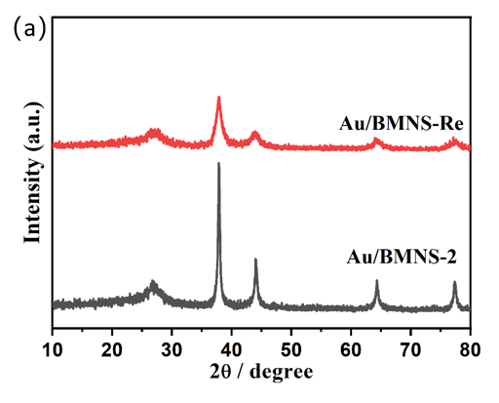

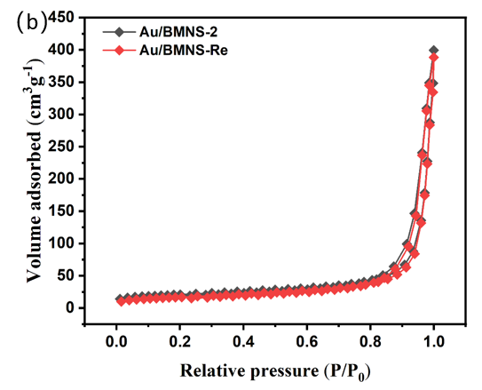
Fig. S5. BET analysis of the catalyst before (Au/BMNS-2) and after five catalytic cycles (Au/BMNS-Re).

Fig. S6. In situ FT-IR adsorption spectra of the prepared catalysts under dark conditions in a CO₂ + H₂O atmosphere, recorded by DRIFTS. (a) BMNS and (b) Au/BMNS-2 in the wavenumber range of 3500–3800 cm⁻¹.

Fig. S7. In situ FTIR spectra of CO₂ reduction over Au/BMNS-2 under light irradiation.

Fig. S8. In situ XPS spectra for B1s.

g-C₃N₄
BMNS
Au/BMNS-2
Fig. S9. The structure of Catalyst used in the DOS calculation.

Table S1 Surface elemental composition of prepared samples based on XPS analysis
Catalyst | C (Atom%) | N (Atom%) | B (Atom%) | Au (Atom%)
g-C₃N₄ | 46.42 | 53.58 | 0 | 0
BMNS | 46.20 | 52.48 | 1.31 | 0
Au/BMNS-2 | 46.55 | 51.22 | 1.50 | 0.72

Table S2 Structural parameters of Au/BMNS-2 before and after catalytic reaction
Sample | Specific surface area (m² g⁻¹) | Average pore size (nm) | Pore Volume  (cm³ g⁻¹)
Au/BMNS-2 | 72.9416 | 34.7847 | 0.6181
Au/BMNS-Re | 68.3375 | 33.5718 | 0.5945

